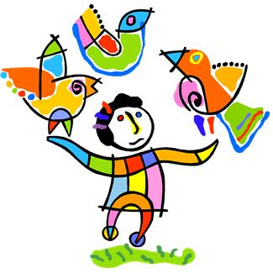Manchester Montessori House

How we foster British values at Manchester Montessori House

Democracy
- The Montessori Method is, at its heart, a method of education that inspires
confidence, self-esteem, and the ability in children to express themselves.
- From experience, children know they will be listened to in our setting.
- Each child‘s learning plan (ILP) supports and guides the decisions that children make on their own, and helps to understand the consequences of those decisions.
- Grace and Courtesy exercises model the taking of turns, sharing and collaboration, as well as encouraging the exchange of views, and respect for those views.

Rule of law
- Grace and Courtesy exercises teach children about right, wrong, injustice and equality.
- Minimal boundaries and rules (to ensure harmony), and persistent reminders about them, encourage children to comply, and to understand the reasons behind them. In many cases, children will police those rules themselves.
- Children learn that any behavior has consequences.

Individual liberty
- The Montessori work cycle allows children the freedom to make their own decisions and to choose their own activities.
- Grace and Courtesy exercises allow children to understand the concept of liberty in others, and to respect it.

Mutual respect for, and tolerance of, those with different faiths and beliefs, and for those without faith.
- The cultural materials teach children their place in the world, and the importance of treating people, animals and plants well.
- The Sun Game teaches the inter-dependence of all life on Earth.
- The Geography part of the curriculum teaches children about different countries and cultures; various festivals are celebrated; similarities and differences between peoples are discussed

- As with the Grace and Courtesy exercises that promote democracy, so the same activities teach that opinions between people can dimer and that differing opinions should be respected.

Review of Policy:
We will monitor our progress and review this policy annually (issued August 2021).
Reviwed in December 2022 by Sylwia Zywotko

